APES PRACTICE Q’s

**1. Which of the following statements regarding developed countries and developing countries is true?**

1. Developed countries are home to twice as many people as developing countries.
2. Developed countries are home to four times as many people as developing countries.
3. Developed countries have more rapid population growth rates than developing countries.
4. Developed countries have lower per capita GNPs than developing countries.
5. Developed countries generally have safer water supplies.

**2. The global human population is closest to which of the following?**

1. 5 billion
2. 6 billion
3. 7 billion
4. 10 billion
5. 12 billion

**3. Human population growth over the last 4,000 years can best be described as**

1. Linear
2. negative
3. oscillating
4. inverted
5. exponential

**4. The degradation of spaces on and surrounding Earth which are outside of the domain/ ownership/ rule of any country is known as:**

1. The common curve
2. The tragedy of the commons
3. The circle of the sustainability.
4. The imminent domain.
5. The tragedy of the cheese.

**5. In the equation, I = P A T, I represents:**

1. resource technology
2. inertia of a population
3. introduced species
4. environmental impact of a population
5. infant mortality

**Refer to the following terms for questions 22-26**

1. Data
2. Theory
3. Control group
4. Hypothesis
5. Experimental group

**6. A possible explanation of observations.**

**7. A well-tested and widely accepted idea, principle, or model**

**8. Contains the chosen variable that is changed in a known way.**

**9. Facts collected by making observations.**

**10. Controlled experiment group in which no variable is changed.**

**11. The first law of energy states that:**

1. doing work always creates heat.
2. altering matter is the best source of energy
3. energy cannot be recycled
4. energy is neither created nor destroyed.
5. Entropy tends to increase

**12. Earth is essentially a(n) system regarding matter and a(n) system regarding energy.**

1. open; open
2. open; closed
3. closed; closed
4. closed; open
5. open; self-sustaining

**13. The amount of energy transferred from an organism on one trophic level to the next trophic level is approximately________%**

1. 1
2. 10
3. 30
4. 50
5. 90

**14. The form of nitrogen most usable to plants is**

1. Ammonia
2. Nitrogen gas
3. Proteins
4. Nitrates
5. Nucleic acids

**15. All of the following increase the amount of carbon dioxide in the atmosphere *except* :**

1. respiration
2. photosynthesis
3. combustion
4. decomposition
5. volcanic eruptions

**For questions 16-18, refer to the energy flow diagram below:**



Producer (500,000 kcal)

Consumer (Human)

Consumer (Perch)

Consumer (Zooplankton)

Consumer

Y

**16. If there are 500,000 kilocalories (kcal) in the producer level, how many kcal will become incorporated in the tissues of the secondary consumers?**

1. 2
2. 50
3. 500
4. 5,000
5. 50,000

**17. How many kcal will become incorporated in the tissues of the tertiary consumers?**

1. 5
2. 50
3. 500
4. 5,000
5. 50,000

**18. The consumer group represented by the perpendicular bar labeled “Y” is known as the:**

1. carnivores
2. decomposers
3. omnivores
4. keystones
5. herbivores

**19. Ants, Bees, Wolves, and Alligators are examples of organisms that are disproportionately important compared to their biomass in an ecosystem, and are therefore termed:**

1. Golden Species
2. Specialist Species
3. Indicator Species
4. Generalist Species
5. Keystone Species

**20. The energy of the sun is primarily the result of:**

1. the fusion of two helium atoms to form carbon
2. the fission of two hydrogen atoms to form helium
3. the fusion of two carbon atoms to form neon
4. the fission of two neon atoms to form carbon
5. the fusion of two hydrogen atoms to form helium

**21. What is Net Primary Productivity?**

1. is the rate at which produces manufacture chemical energy through photosynthesis
2. is the rate at which producers use chemical energy through respiration
3. is the rate of photosynthesis plus the rate of cellular respiration
4. is the rate at which energy for use by consumers is stored in biomass
5. is the rate at which plants and other producers use photosynthesis to make more plant materials

**22. A group of individuals of the same species occupying a given area at the same time is called a**

1. species
2. population
3. community
4. genus
5. subspecies

**23. The place where an organism lives is its**

1. niche
2. community
3. ecosystem
4. habitat
5. biome

**24. A community of living organisms interacting with one another and the physical and chemical factors of their nonliving environment is called**

1. a species
2. an ecosystem
3. a population
4. a lithosphere
5. a biosphere

**25. Which of the following includes all the others?**

1. species
2. population
3. community
4. organism
5. biome

**26. What percent of the incoming solar energy is captured by the green plants and bacteria and fuels photosynthesis to make the organic compounds that most life-forms need to survive.**

1. 90%
2. 66%
3. 40%
4. 10%
5. less than 1%

**27. The cycle most responsible for linking the other biogeochemical cycles is the:**

1. carbon cycle
2. nitrogen cycle
3. phosphorus cycle
4. hydrologic cycle
5. sulfur cycle

**28. Which of the following ecosystems has the highest average net primary productivity?**

1. agricultural land
2. open ocean
3. temperate forest
4. swamps and marshes
5. lakes and streams

**29. Humans are most likely to alter the earth’s thermostat through their impact on the compound.**

1. carbon dioxide
2. nitrogen gas
3. phosphate
4. hydrogen sulfate
5. carbohydrates

**30. The major plant nutrient most likely to be a limiting factor is**

1. phosphorous
2. calcium
3. manganese
4. potassium
5. magnesium

**31. The portion of a species resource (biological, chemical, and physical) which a particular species actually utilizes is known as the:**

1. Reserve niche
2. Conservation niche
3. Basic niche
4. Fundamental niche
5. Realized niche

**32. The two most important factors in climate are**

1. temperature and insulation.
2. precipitation and pressure.
3. humidity, clouds, and wind.
4. temperature and precipitation.
5. wavelengths or light and atmospheric particulates.

**33. During an El Nino-Southern Oscillation (ENSO),**

1. prevailing easterly winds weaken.
2. surface water along the South and North American coasts becomes cooler.
3. upwellings of cold, nutrient- rich water are suppressed.
4. upwellings of warm, nutrient-poor water are suppressed.
5. primary productivity increases.

**For questions 34–38, refer to the diagram below.**

1. forest
2. leeward
3. rain shadow effect
4. desert
5. windward

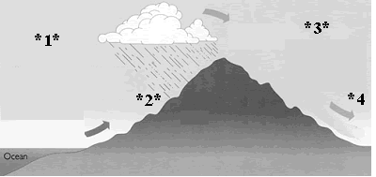

**34. Biome type found here (*2*):**

**35. Biome type found here (*4*):**

**36. The ____________ side of the mountain (*1*):**

**37. The phenomenon associated with the moisture and mountains:**

**38. The ____________ side of the mountain (*3*):**

**39. The limiting factor of the rain forest is**

1. Water
2. Soil Nutrients
3. Temperatures
4. Light
5. Wind

**40. The desert is an area where**

* 1. Average annual precipitation is less than 25 centimeters
  2. Evaporation is slow
  3. The atmosphere (troposphere) serves as an excellent insulator

1. I only
2. II only
3. III only
4. I and II only
5. I, II, and III

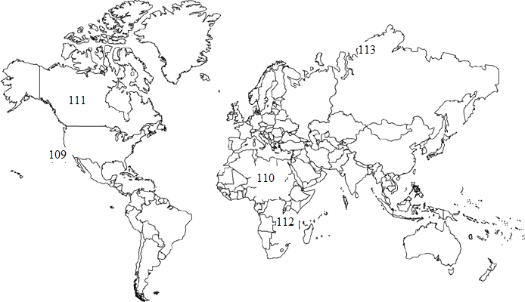

**For questions 109-113, refer to the diagram below:**

1. desert
2. boreal forest
3. tropical savanna
4. chaparral
5. polar grasslands

**41. The most probable chain of cause and effect contributing to patterns of earth’s biomes is**

1. Incoming solar energy and the earth’s geometry create climate patterns which create air and ocean currents which create biome patterns.
2. Incoming solar energy and the earth’s geometry create air and ocean currents which create climate patterns which create biome patterns.
3. Incoming solar energy and the earth’s geometry create climate patterns which create biome patterns which create air and ocean currents.
4. Air and ocean currents determine incoming solar energy and the earth’s geometry which create climate patterns which create biome patterns.
5. Incoming solar energy and the earth’s geometry create air and ocean currents which create biome patterns which create climate patterns.

**42. The gradual change in species composition of a given area is called:**

1. species distribution
2. ecological succession
3. mutualistic dynamism
4. background extinction
5. genetic drift

**53. A species which serves as an early warning sign that a community or ecosystem is being altered or degraded is termed:**

1. a keystone species
2. a native species
3. an indicator species
4. an introduced species
5. an alarm species

**For questions 44-48, refer to the following choices regarding species interactions:**

1. mutualism
2. commensalisms
3. parasitism
4. exploitation competition
5. interference competition

**44. A relationship in which both species clearly benefit.**

**45. Competing species have roughly equal access to a specific resource but differ in how fast or efficiently they utilize it.**

**46. A relationship in which one species benefits and the other species is harmed.**

**47. Contending species end up not having equal access to some resources; e.g., one species chases another species away.**

**48. A relationship in which one species benefits and the other species is neither helped nor harmed.**

**49. Primary succession must occur prior to secondary succession in order to:**

1. Change soil to rock
2. Change Ice to water
3. Change rock to soil
4. Change soil to lichen
5. Change lichen to algae

**50. The dividing up of limited assets, materials, and other desired items so that species with similar needs use them at different times, in different ways, or in different places is known as:**

1. Exploitation Competition
2. Resource Partitioning
3. Predator-Prey Relationships
4. Resource Equilibrium
5. Precautionary Allocation

**51. The biotic potential of a population:**

1. is the maximum reproductive rate of population
2. is the current rate of growth of a population
3. is an expression of how many offspring survive to reproduce
4. can be determined only by studying an age structure diagram
5. determines the fitness of a population

**52. Density dependent population controls include all of the following *except:***

1. Disease
2. human destruction of habitat
3. parasitism
4. competition for resources
5. predation

**53. An r-selected species generally:**

1. has a low biotic potential
2. is small and short lived
3. gives much parental care to its offspring
4. survives to reproduce
5. lives in a stable environment

**54. Which of the following best describes the survivorship curve you would expect to find for a mountain gorilla?**

1. late loss (type I)
2. constant loss (type II)
3. early loss (type III)
4. no loss (type IV)
5. cyclical loss (type V)

**55. Density independent population controls include all of the following except**

1. drought
2. fire
3. resource competition
4. unfavorable chemical changes in the environment
5. unseasonable temperature changes

**56. Which of the following survivorship curve would correspond best with a Species that is an r-strategist ? [x-axis = age (time); y-axis = population (size)]**

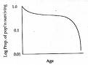 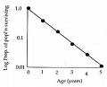 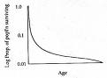

**A B C**

**57. Wolves controlling deer populations is an example of**

1. bottom-up population control
2. bottom out population control
3. producer level population control
4. top-up population control
5. top-down population control

**58. Which of the following types of species is least vulnerable to habitat fragmentation?**

1. generalists
2. specialists
3. large predators
4. migratory species
5. species requiring large territories.

**59. Dieback is not immediate after a population has overshot the carrying capacity because it takes time:**

1. To produce new offspring
2. To locate a compatible mate
3. For organisms to further deplete resources, become weaker, and for some to perish
4. For the intrinsic rate of increase to reach equilibrium with gross primary productivity
5. For the birth rate to equal the total solar output per unit area

**60. An endangered species is any species that**

1. is still abundant in its natural range but is declining in numbers
2. has naturally small numbers of individuals
3. has limited geographic range areas
4. plays a role which influences many other organisms in an ecosystem
5. has so few individual survivors that the species could soon become extinct over all or most of its natural range

**61. The best estimates for the number of species on earth are generally closest to:**

1. 12-14 thousand
2. 12-14 million
3. 12-14 billion
4. 12-14 trillion
5. 40-100 billion

**62. The grizzly bear is extinct prone for which of the following reasons?**

* 1. high reproductive rate
  2. feed at high trophic levels
  3. requires small territories and narrow corridors
     1. I only
     2. II only
     3. III only
     4. I and III only
     5. I, II, and III

**63. Fossils and radioactive dating indicate that _____ major mass extinctions have taken place in the past 500 million years, with the most recent mass extinction taking place approximately ____ years ago.**

1. 5; 300,000
2. 2; 400,000
3. 4; 5,000
4. 5; 65 million
5. 5; 300 million

**64. The greatest threat to most species is**

1. Reduction of habitats
2. Water pollution
3. Parasites
4. Bioaccumulation
5. Sport Hunting

**65. Which of the following are suggested to reduce the threats from nonnative species?**

* 1. Increase Inspections
  2. Empty bilge water from vessels in the calm-water ports instead of the more turbulent open ocean
  3. Use legislation which targets goods and materials which are imported
     1. I only
     2. II only
     3. III only
     4. I and III only
     5. I, II, and III

**66. Which of the following statements is NOT true regarding the United Sates Endangered Species Act?**

1. The Endangered Species Act of the United States includes the listing of species which have been deemed threatened or endangered.
2. The National Marine Fisheries service is authorized to list certain species on the Endangered Species List.
3. The U.S. Fish and Wildlife Service is authorized to list certain species on the Endangered species list.
4. The Environmental protection agency is authorized to list certain species on the Endangered Species List.
5. Following the listing of a species, a plan to help this particular species recover is supposed to be prepared.

**67. Which of the following statements is true regarding Environmental Resistance?**

* 1. It consists of temperature variations in the biosphere.
  2. It is magnified for species which have specialized niches.
  3. It is increased for species which cannot migrate nor live in other habitats.
     1. I only
     2. II only
     3. III only
     4. II and III only
     5. I, II, and III

**68. Carrying capacity**

1. Is the number of individuals of a given species that can be sustained indefinitely in a given space or area
2. Is a fixed quantity
3. Is typically not affected by seasonal fluctuations in food supply, water, hiding places, and nesting sites.
   1. I only
   2. II only
   3. III only
   4. I and III only
   5. I, II, and III

**69. Birds are considered good indicator species because they:**

1. Are difficult to track and count.
2. Live in a narrow climate range
3. Live in every biome
4. Respond slowly to environmental change.
5. Are not effected by DTT

**70. Which of the following lists the major steps of cultural eutrophication, in the order in which they occur?**

1. nutrient input, algal bloom, nutrient depletion, algal die-off, decomposition, decreased dissolved oxygen, fish suffocate
2. nutrient input, algal bloom, decomposition, algal-die off, increased dissolved oxygen, fish suffocate, nutrient depletion
3. nutrient input, decreased dissolved oxygen, algal bloom, nutrient depletion, decomposition, algal die-off, fish suffocate
4. nutrient input, algal bloom, algal die-off, fish suffocate, nutrient depletion, decreased dissolved oxygen, decomposition
5. nutrient input, increased dissolved oxygen, algal bloom, nutrient depletion, algal die off, decomposition, fish suffocate

**For questions 71-72, refer to the generalized ecological pyramids and the choices below: Select the best choice for each to label the pyramid type**

1. pyramid of energy
2. pyramid of biomass
3. pyramid of consumers
4. pyramid of producers
5. pyramid of numbers

**Question 71**

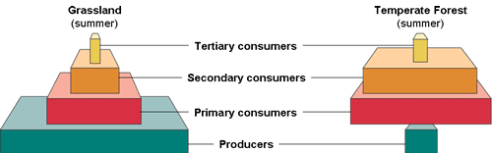

**Question 72**

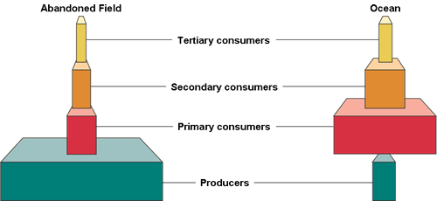

**71. Which of the following species would least likely show the harmful effects of biological magnification?**

1. Falcon
2. Bald eagle
3. Hummingbird
4. Pelican
5. Osprey

**72. A country currently has a population of 200 million and an annual growth rate of 3.0%. If the growth rate remains constant, after 70 years, the population will be approximately:**

1. 260 million
2. 500 million
3. 600 million
4. 800 million
5. 1600 million

**73. In 1999, Australia had a crude birth rate of 14 and a crude death rate of 7. Based on these figures, the annual rate of increase or decrease, expressed as a percent, equals:**

1. 0.007%
2. 0.07%
3. 0.7%
4. 7.0%
5. 70.0%

**74. Determine the growth rate for a population of 100,000 people when there were 450 births, 80 deaths, 70 immigrants, and 40 emigrants in a given year:**

1. 0.04%
2. 0.4%
3. 4.0%
4. 40.0%
5. 400.0%

**75. Which of the following are considered the two most useful indicators of overall health in a country or region?**

1. birth rate and death rate
2. replacement-level fertility and total fertility rate
3. life expectancy and death rate
4. life expectancy and infant mortality rate
5. birth rate and infant mortality rate

**76. In the absence of high mortality, the major determining factor for population growth is________.**

1. crude birth rate
2. crude death rate
3. total fertility rate
4. replacement-level fertility
5. infant mortality

**77. In the demographic transition model, the specific transition which is associated with the declining death rates is known as the_____ transition.**

1. Three-or-below
2. Epidemiological
3. Dollar-a-Day
4. Baby-Boom
5. Fertility

**78. Demographic Transition refers to:**

1. a requirement for a population to reach a specific size before it becomes stable
2. The slowing down in the growth of a population as it approaches the carrying capacity.
3. The changes in the growth, birth rate, and death rate which a nation experiences as it goes through industrialization.
4. The decline in death rates that occurred when the germ theory of disease was discovered.
5. Migration from overpopulated nation’s different countries, mainly MDC’s.

**79. The predator-prey relationship between the Canadian lynx and the snowshoe hare shows what type of control?**

1. top-down population control
2. bottom-up population control
3. not mutually exclusive, both a and b
4. the life cycle of the natural fauna influence the population of both species
5. there is no influence on the population by either the number of snowshoe hares or Canadian lynxes.

**80. What factors decreased death rates?**

1. increase food supply and distribution
2. better nutrition
3. improvements in medical and public health technology
4. safer water supplies
5. all of the above

**For questions 81-82, refer to the demographic transition figure below.**

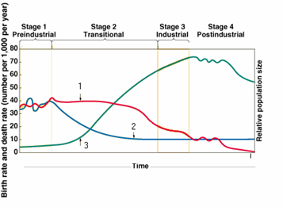

**81. Zero population growth is associated with (graph)**

1. phase I
2. phase II
3. phase III
4. phase IV
5. phase I and IV

**82. The rate of population growth starts to slow down at which point? (Graph)**

1. the end of phase I
2. the middle of phase II
3. the beginning of phase III
4. the end of phase III
5. the middle of phase IV

**83. During the past 100 years, human population growth is primarily due to a ____ in the ____.**

1. decrease; death rate
2. increase; death rate
3. decrease; birth rate
4. increase; infant mortality rate
5. increase; birth rate

**For questions #84 – 85, use the following diagram:**



**84. What evolutionary process occurs through geographic isolation and reproductive isolation?**

* 1. coevolution
  2. speciation
  3. convergence
  4. extinction

**85. What geographical types might have caused the separation of these two species of fox?**

1. mountains
2. water
3. glaciers
4. all of the above

**86. Changes in population dynamics occur in response to:**

* 1. environmental stress
  2. biotic potential
  3. changes in environmental conditions
     1. I only
     2. II only
     3. III only
     4. I and III only
     5. I, II, and III

**87. Which two countries combined have approximately 1/3 of the world’s total population?**

1. China and India
2. Russia and the United States
3. China and the United States
4. Mexico and the United States
5. China and Russia

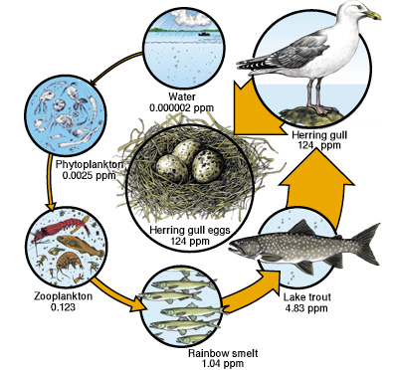

**Using the diagram above, answer the following questions (88 –89):**

**88. This diagram is an example of:**

1. biomagnification
2. neutralization
3. eutrophication
4. non-point source pollution
5. point source pollution

**89. This increase of pollutants in the eggs caused what to happen?**

1. Certain bird populations decreased
2. Egg shells broken when the adults sat on the eggs
3. The near extinction of the California Brown Pelican
4. The biological extinction of the Bald Eagle on most the Channel Islands.
5. All of the above

**90. DDT**

1. is biologically magnified in food chains
2. has helped save the lives of people who live in areas with malaria
3. has a high biological persistence
4. all of the above

**91. The Commons is based on the concept that different owners share a common land that they then share the resources. Explain what happens when the Tragedy of the Commons occurs.**

1. Land degrades due to over consumption
2. The food resources are used up
3. No planning for future use of the land
4. All of the above
5. None of the above

**92. Easter Island is a good example of the Tragedy of the Commons because:**

1. The society was based on the palm trees
2. They had an impressive society
3. The palm trees were used faster than they regenerated.
4. Springs and streams dried up because the lost trees didn’t absorb the water
5. Trees were not available to make canoes to catch fish

**93. What is the main premise of the Law of Conservation of Matter?**

1. Matter can be destroyed.
2. Matter can not be rearranged.
3. We can never create nor destroy matter.
4. What is matter?
5. Matter is constantly being made.

**94. What is the main premise of the First Law of Thermodynamics?**

1. Energy can be destroyed.
2. Energy can not be rearranged.
3. Energy is constantly being made.
4. We can never create nor destroy energy.
5. What energy?

**95. What is the main premise of the Second Law of Thermodynamics?**

1. Energy always stays in the same form.
2. When energy changes form, you end up with less usable energy.
3. Energy is a constant.
4. What is thermodynamics?

**96. The process of natural selection is the following:**

1. survival of the fittest
2. complex organisms evolved to simpler organisms
3. organisms struggle to obtain resources to survive and reproduce
4. simpler organisms evolved complex organisms
5. that chemical reactions were needed to form the first cells

**97. The ecological principle know as the limiting factor principle is:**

1. biotic factors such food sources limit population size.
2. too much or to little of any abiotic factor can limit or prevent population growth.
3. the limited soil in some areas limit the population size.
4. water is the limiting factor
5. species outside their tolerances limit population growth.

**98. Ninety-nine percent of the volume of air in the troposphere consists of oxygen and**

1. nitrogen
2. argon
3. carbon dioxide
4. sulfur dioxide
5. water vapor

99.  **If a nation has a growth rate 2.0 %, how many years will it take for the population to double in size?**

1. 0.35 years
2. 3.5 years
3. 35 years
4. 350 years
5. 3500 years

**100. With ______, a quantity increases by a constant amount per unit of time.**

1. linear growth
2. exponential growth
3. both of the above
4. neither of the above

**101. The rule of 70 is a quick way to estimate**

1. carrying capacity
2. gross national product (GNP)
3. doubling time
4. per capita income

**102. All of the following occurred during the shift from hunting and gathering culture to agricultural societies *except*:**

1. use of fire
2. the domestication of animals
3. cultivation of wild plants
4. clearing of land for cultivation
5. practiced sustainable cultivation

**103. The Rule of 70 as used in environmental science is defined as followed:**

1. How large the population will be in 70 years
2. The time it takes for a society to move from the agricultural revolution to the industrial revolution.
3. The number of years the population takes to double.
4. A card game.
5. All of the above.

**104. If a nation has a growth rate 2%, how many years will it take for the population to double in size?**

1. 2 years
2. 10 years
3. 20 years
4. 35 years
5. 350 years

**105. Phytoplankton in a freshwater ecosystem are**

1. producers
2. primary consumers
3. secondary consumers
4. tertiary consumers
5. omnivore

**106. Zooplankton in a saltwater ecosystem are**

1. producers
2. primary consumers
3. secondary consumers
4. tertiary consumers
5. decomposer

**For questions #107 – 108, use the following:**

1. community
2. population
3. ecosystem
4. biosphere
5. organism

**107. Which of the following levels of organization is the most inclusive?**

**108. A(n) ______ includes both living and nonliving components.**

**For questions #109 – 110, use the following answers:**

1. stratosphere
2. mesosphere
3. troposphere
4. lithosphere
5. space

**109. The ______ is the inner layer of the earth's atmosphere that contains its air.**

**110. The ozone layer is part of the**

**111. A k-selected species is characterized by which of the following?**

1. fewer offspring
2. late reproductive age
3. larger adults
4. low population growth rate
5. all of the above

**112. A nation currently has a population of 100 million and an annual growth rate of 3.5%. If the growth rate remains constant, what will be the population of this nation in 40 years?**

1. 150 million
2. 200 million
3. 300 million
4. 400 million
5. 500 million

**113. Populations are dynamic and change in response to environmental stress or changes in environmental conditions. These changes include:**

1. size of the population (number of individual)
2. density of the population
3. dispersion pattern
4. age distribution
5. all of the above

**114. Which of the following is NOT an ecological lesson that can be learned from how nature works?**

1. solar energy is the primary source of energy
2. ecosystems replenish nutrients and dispose of waste
3. biodiversity helps maintain sustainability
4. all organisms have a right to survival
5. there are limits to population growth and resource consumption

**ANSWERS**

1. E
2. C
3. E
4. B
5. D
6. D
7. B
8. E
9. A
10. C
11. D
12. D
13. B
14. X
15. B
16. D
17. C
18. B
19. E
20. E
21. D
22. B
23. D
24. B
25. E
26. E
27. D
28. B
29. A
30. A
31. E
32. D
33. A & C
34. A
35. D
36. E
37. C
38. E
39. D
40. A

109. D

110. A

111. B

112. C

113. E

1. B
2. B
3. C
4. A
5. E
6. C
7. D
8. B
9. C
10. B
11. A
12. B
13. B
14. A
15. C
16. C
17. E
18. A
19. C
20. E
21. B
22. B
23. D
24. A
25. E
26. D
27. E
28. A
29. C
30. A
31. E
32. B

71. C

72. E

73. C

1. B
2. D
3. C
4. B
5. C
6. A
7. E
8. A (some graphs will show stage four as zero pop growth but this graph show stage 4 as decline pop growth)
9. D
10. A
11. B
12. D
13. D
14. A
15. A
16. E
17. A
18. D
19. C
20. C
21. D
22. B
23. A
24. B
25. A
26. C
27. B
28. C
29. E
30. C
31. D
32. A
33. B
34. D
35. C
36. C
37. A
38. E
39. D
40. E
41. D