CMS SCI EEN 2.1.1, 2.1.3, 2.2.1
Student
Date

2. | A mountain showed the following change in profile over millions of years.  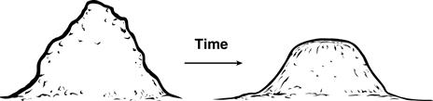  What happened to most of the material removed from the mountain?
 | A. The material weathered to form new sediments.
 | B. The material was absorbed by plant roots.
 | C. The material disintegrated from exposure to sunlight.
 | D. The material was destroyed by chemical reactions.

3. | The weathering of landforms depends on various factors. Which area would most likely have the fastest rate of chemical weathering?
 | A. freezing and dry regions
 | B. warm and moist regions
 | C. cool and humid regions
 | D. hot and dry region

4. | A science class designed a poster to show how the barrier islands along the Florida coastline formed. The students showed the effects of wind, waves, and tides on the sand that formed these islands. In the poster, which pair of systems should the students say most affected barrier island formation?
 | A. the hydrosphere and atmosphere
 | B. the atmosphere and lithosphere
 | C. the biosphere and hydrosphere
 | D. the lithosphere and biosphere

5. | Fences are put along some beaches.  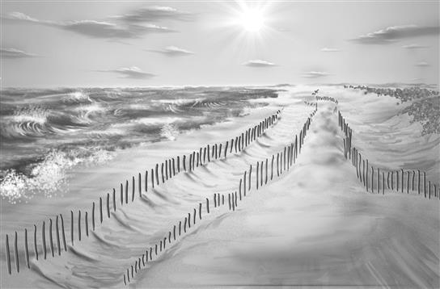  For which reason are the fences most likely placed along beaches?
 | A. to increase water erosion
 | B. to prevent wind erosion
 | C. to increase weathering
 | D. to prevent deposition

6. | In some places along the Gulf of Mexico, barrier islands are eroding at rates exceeding 20 meters per year. Erosion of the barrier islands is so severe that their ability to function as buffers for wetlands is being reduced.  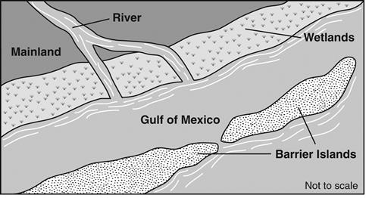  Which natural phenomenon is most likely responsible for this erosion?
 | A. drought
 | B. tornadoes
 | C. mudslides
 | D. hurricanes

7. | Biotic forces can cause changes to the surface of Earth. Which is the best example of living organisms causing weathering?
 | A. Beavers building a dam across a stream.
 | B. Cattle walking and grazing in a grassland.
 | C. Salmon making nests for their eggs in a stream.
 | D. Tree seedlings growing and forming cracks in rocks.

8. | Why are fossils rarely found in metamorphic or igneous rock?
 | A. Chemicals toxic to living organisms are released during formation of these rocks.
 | B. Heat and pressure are great enough to destroy the structure of fossils found in these rocks.
 | C. Decay of radioactive isotopes changes the fossils into a different rock structure.
 | D. Intense magnetic fields found where these rocks form keep organisms from living there.

9. | An incomplete diagram of the rock cycle is shown.  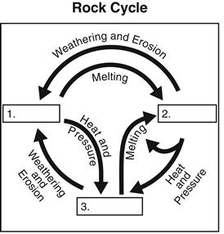  Which terms should be placed in the boxes labeled 1, 2, and 3?
 | A.
 | B.
 | C.
 | D.

10. | Humus, which is formed by th decay of plant and animal matter, is important for the formation of most
 | A. soils
 | B. minerals
 | C. sediment
 | D. bedrock

11. | Examine the diagram below and answer the question.  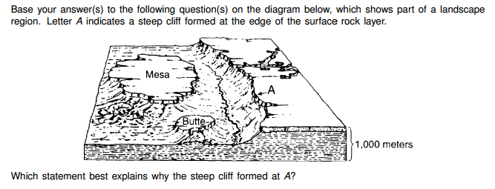
 | A. The surface layer is older than the rock layers below.
 | B. The surface layer was deposited as loose volcanic ash.
 | C. The surface layer is more resistant to weathering than the other layers.
 | D. THe surface layer contains many fossils.

12. | The formation of soil is primarily a result of
 | A. stream erosion and mass movement
 | B. stream deposition and run off
 | C. precipitation and wind erosion
 | D. weathering and biological activity

13. | A student observes the Milky Way galaxy in the night sky. Which characteristic of the galaxy makes it visible?
 | A. The galaxy’s stellar nebulae reflect the Sun’s light.
 | B. Billions of stars in the galaxy carry out nuclear fusion.
 | C. Tons of compressed matter begin to radiate visible light from the galaxy center.
 | D. The galaxy spins at a speed that generates a large amount of molecular friction.

14. | What is the primary means through which the Sun warms Earth?
 | A. fluctuation of subatomic particles
 | B. fluctuation of gravitational fields
 | C. transfer of energy through conduction
 | D. transfer of energy by electromagnetic waves

15. | A direct alignment of bodies in the solar system can occur.  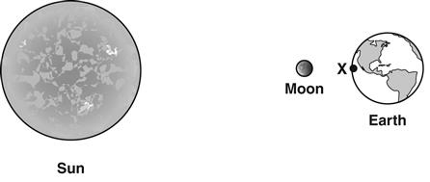  This alignment causes which phenomenon at Point X on Earth?
 | A. low tides
 | B. full moon
 | C. solar eclipse
 | D. winter season

16. | Raul records the sunrise time in his town once per month for one year. His results are shown in the table.  Sunrise Times for Miami, Florida  Date Sunrise Time  January 1 7:34 a.m.  February 1 7:28 a.m.  March 1 7:04 a.m.  April 1 7:27 a.m.  May 1 6:54 a.m.  June 1 6:36 a.m.  July 1 6:38 a.m.  August 1 6:55 a.m.  September 1 7:14 a.m.  October 1 7:30 a.m.  November 1 7:51 a.m.  December 1 7:16 a.m.  Which two characteristics of Earth most account for the trend in this data?
 | A. Earth’s tilt and period of revolution
 | B. Earth’s distance from the Sun and period of revolution
 | C. Earth’s tilt and distance from the Sun
 | D. Earth’s distance from the Sun and period of rotation

17. | The diagram shows the tilt of Earth and the angle of arriving sunlight caused by this tilt.  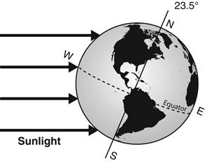  Which conclusion is supported by the diagram?
 | A. The equator has the greatest number of deserts.
 | B. The Northern Hemisphere is experiencing daytime.
 | C. The tilt of Earth is causing icebergs to melt.
 | D. The Southern Hemisphere is experiencing summer.

18. | Earth travels on an elliptical orbit around the Sun.  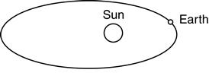  When Earth is at the point labeled on the diagram, it moves most quickly in its orbit. Which best explains this more rapid motion of Earth?
 | A. The amount of solar heat reaching Earth is greatest at this point.
 | B. The Sun’s gravitational pull on Earth is strongest at this point.
 | C. Earth is closest to the Sun’s magnetic field at this point.
 | D. Earth is closest to the Sun’s radioactivity at this point.

19. | Earth’s spherical shape results in an uneven distribution of sunlight reaching Earth’s surface.  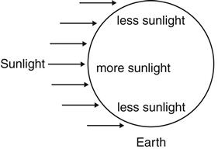  This uneven distribution is most directly responsible for differences in which climatic variable at different latitudes on Earth’s surface?
 | A. wind speed
 | B. temperature
 | C. annual rainfall
 | D. average humidity

20. | All of these types of waves travel from the Sun to Earth except
 | A. light waves.
 | B. sound waves.
 | C. infrared waves.

21. | The length of a year is determined by the amount of time it takes
 | A. the Moon to revolve around Earth.
 | B. Earth to revolve around the Sun.
 | C. Earth to rotate on its axis.
 | D. the Sun to rotate on its axis.

22. | 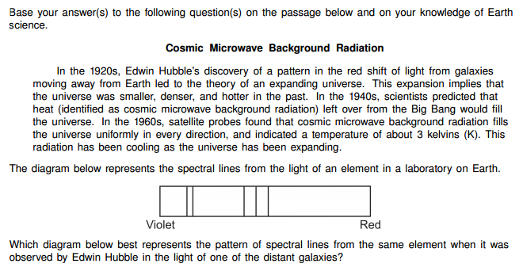
 | A.
 | B.
 | C.
 | D.

23. | 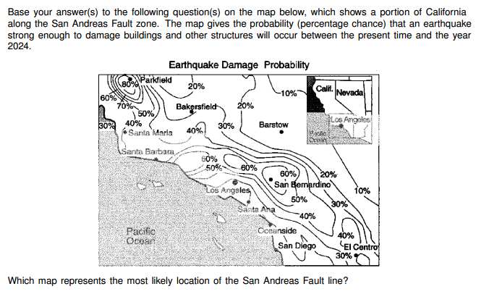
 | A.
 | B.
 | C.
 | D.

24. | 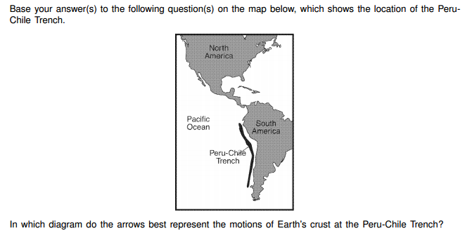
 | A.
 | B.
 | C.
 | D.

25. | 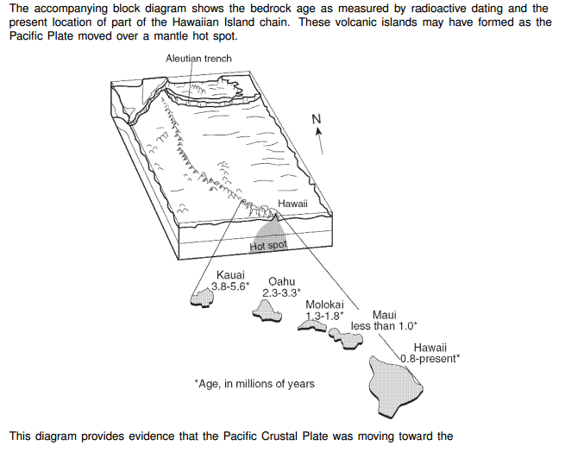
 | A. south
 | B. east
 | C. southwest
 | D. northwest

26. | 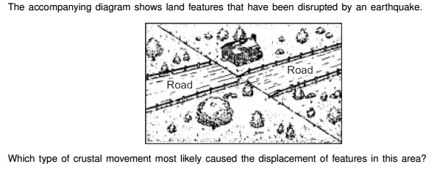
 | A. vertical lifting of surface rock
 | B. folding of surface rock
 | C. down-warping of the crust
 | D. movement along a transfrom plate boundary

27. | 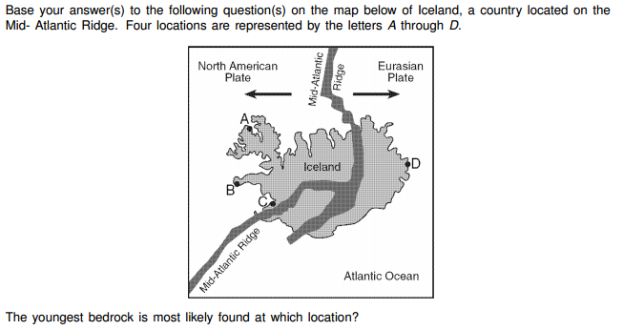
 | A. A
 | B. B
 | C. C
 | D. D

28. | 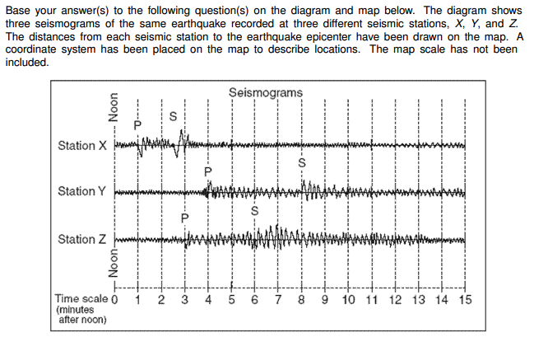  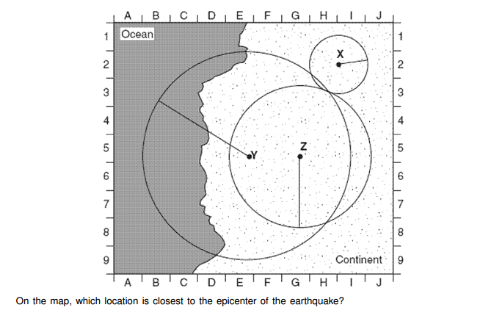
 | A. E-5
 | B. G-1
 | C. H-3
 | D. H-8

29. | 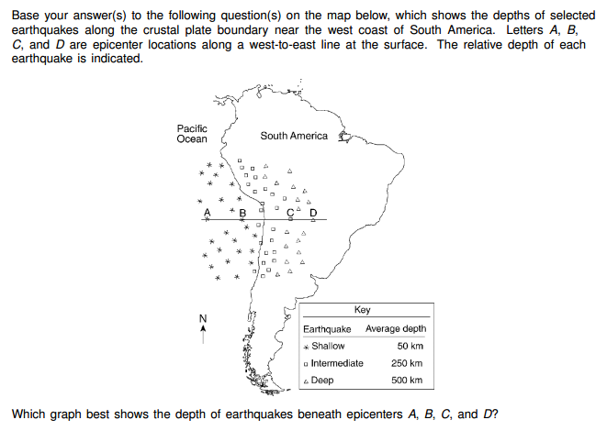
 | A.
 | B.
 | C.
 | D.

30. | An earthquake's magnitude can be determined by
 | A. analyzing the seismic waves recorded by a seismograph
 | B. calculating the depth of earthquake faulting
 | C. calculating the time the earthquake occurred
 | D. comparing the speed of S-waves and P-waves

31. | 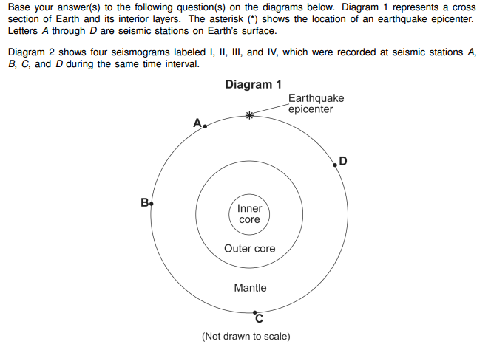  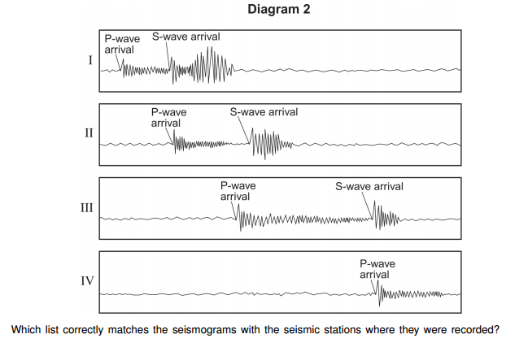
 | A. Seismogram I - Station A Seismogram II - Station B Seismogram III - Station C Seismogram IV - Station D
 | B. Seismogram I - Station B Seismogram II - Station D Seismogram III - Station A Seismogram IV - Station C
 | C. Seismogram I - Station C Seismogram II - Station B Seismogram III - Station D Seismogram IV - Station A
 | D. Seismogram I - Station A Seismogram II - Station D Seismogram III - Station B Seismogram IV - Station C

32. | 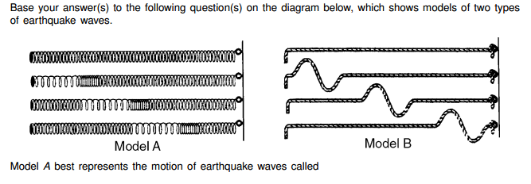
 | A. P-waves (compressional waves) that travel faster than S-waves (shear waves) shown in model B
 | B. P-waves (compressional waves) that travel slower than S-waves (shear waves) shown in model B
 | C. S-waves (shear waves) that travel faster than P-waves (compressional waves) shown in model B
 | D. S-waves (shear waves) that travel slower than P-waves (compressional waves) shown in model B

