Absorption & Radiation by Land & Water

Objective: To describe the comparative rates at which water and land surfaces heat and cool

Introduction: Why do millions of people go to coastal beaches like Jones Beach in the summer? Approximately 70% of Earth’s surface is covered by water. Water has a higher specific heat than soil, thereby causing unequal heating, which significantly affect local and worldwide weather patterns. Notice in the Earth’s Heat Equator diagram that the heat equator lines are further apart from each other over land versus water. 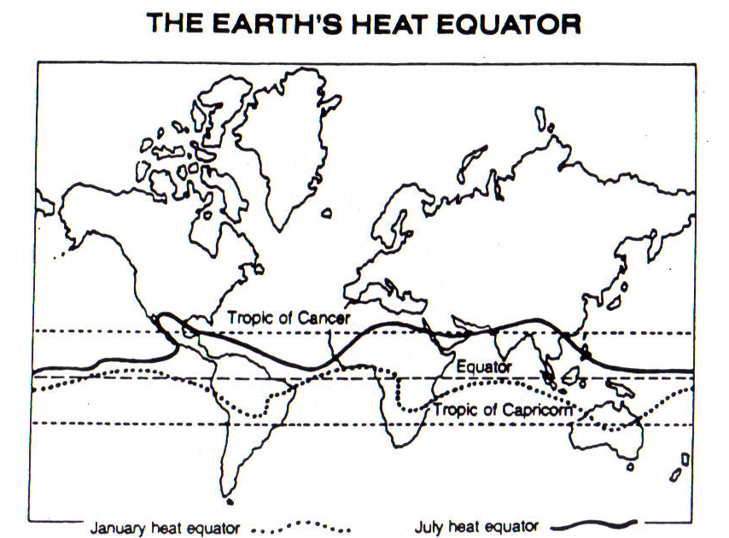
Vocabulary:

Heat equator

Specific heat

Radiative balance

Materials: 2 identical cans 2 thermometers heat lamp metric ruler
Triple beam balance Room temperature soil and water ring stand clamp

Diagram for Lab Set-up
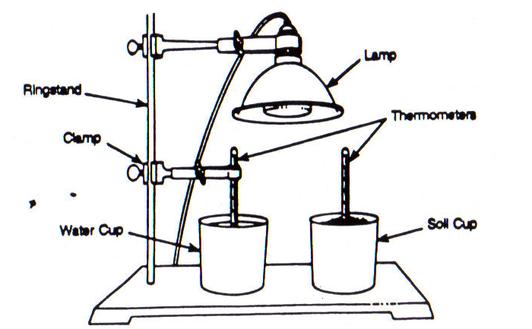
Procedure:
- Fill one can half full with room temperature water.
- Fill the second can half full with sand.
- Make sure that both thermometers are equal in temperature; otherwise ask for a new set of thermometers. Place a thermometer in each can so that the bulb if the thermometer is just below the can’s contents.
- Allow the thermometers to reach room temperature. Enter that temperature in the TIME 0 section on your Data Table.
- Place two cans under the heat lamp and adjust the lamp so that both cans will receive equal energy.
- Turn on the heat lamp and take temperature readings at ONE minute intervals for a time period of ten minutes. Record these temperature readings on your Data Table.
- At the end of 10 minutes, TURN OFF the lamp and remove it from the area next to the two cans. Continue reading and recording of the thermometers, each minute for ten more minutes.
- Make a line graph show both sets of data on the same set of axes. Use a different color or symbol for each curve drawn.
Observations: Data Table

Heat Lamp ON |  |  |  | Heat Lamp OFF and AWAY
Time (min) | Soil temp (°C) | Water temp. (°C) |  | Time (min) | Soil temp. (°C) | Water temp. (°C)
0 |  |  |  | 11
1 |  |  |  | 12
2 |  |  |  | 13
3 |  |  |  | 14
4 |  |  |  | 15
5 |  |  |  | 16
6 |  |  |  | 17
7 |  |  |  | 18
8 |  |  |  | 19
9 |  |  |  | 20
10

Observations: Graph
KEY
Soil ___
Water - - -

Time (min)

Questions:
- According to your graph, which can heat more rapidly? How does your graph illustrate this?

- According to your graph, which cooled more rapidly?

- Which is a better absorber and radiator of heat energy, soil or water?

- Which material has the higher specific heat, soil or water?

- By 3 o-clock in the afternoon on a summer day, where would the air be cooler, over the ocean or over the nearby land?

- Referring to the question above, how would the density of air over the ocean compare to the density of the air over the nearby land?

- Referring the Earth’s Heat Equator Diagram on the first page, why does the heat equator for January bend further into the Southern Hemisphere over the continents of South America and Africa than it bends over the ocean areas?

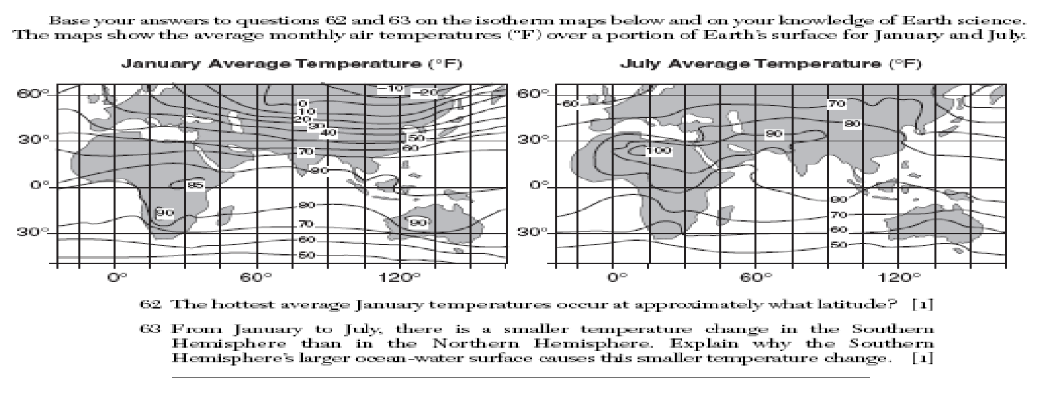
- Base your answers to the following questions based on the isotherm maps above, which show the average monthly temperatures (°F) over a portion of Earth’s surface for January and July. The hottest average January temperatures occur at approximately what latitude?

- Explain why there is a smaller temperature change in the Southern Hemisphere than in the Northern Hemisphere from January to July.

Conclusion Questions:
- How do water and land surface differ in their abilities to absorb and radiate heat energy?

- Why does the heat equator move farther into the Northern Hemisphere in July than it moves into the Southern Hemisphere?

