FINAL EXAM PRACTICE TEST #2: Water, Oceans, & Atmosphere

1. | Which human activity directly affects the quality of freshwater resources?
 | A. depleting the ozone layer
 | B. burning gasoline in car engines
 | C. storing nuclear waste in casks
 | D. allowing runoff from agricultural fields

2. | 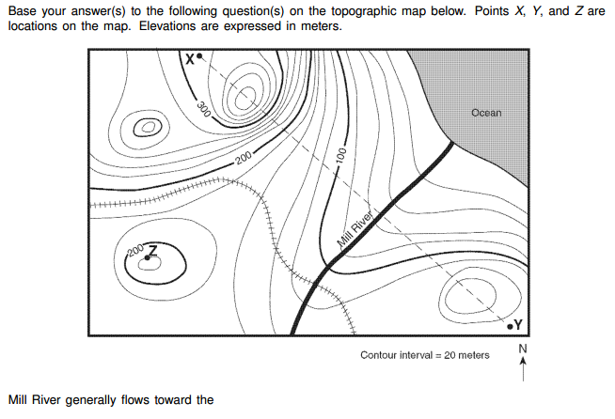
 | A. southeast
 | B. southwest
 | C. northeast
 | D. northwest

3. | The water table usually rises when there is
 | A. a decrease in the amount of infiltration
 | B. a decrease in the amount of surface area covered by vegetation
 | C. an increase in the amount of precipitation
 | D. an increase in the slope of the land

4. | 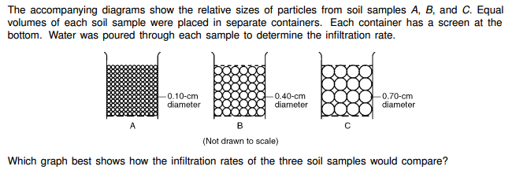
 | A. |  | B.
 | C. |  | D.

5. | The greatest amount of rainwater infiltration occurs on the side of a hill if the surface of permeable soil has
 | A. small soil particles and a steep slope
 | B. small soil particles and a gentle slope
 | C. large soil particles and a steep slope
 | D. large soil particles and a gentle slope

6. | 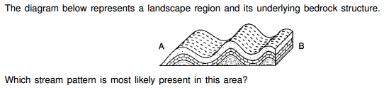
 | A.
 | B.
 | C.
 | D.

7. | The accompanying cross section represents a forested area in North Carolina.  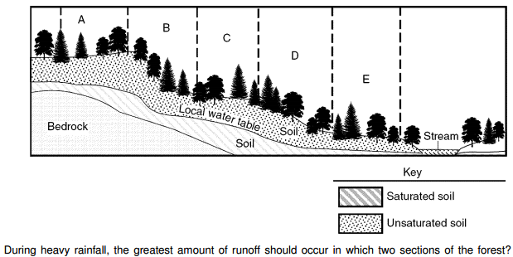
 | A. A and B |  | B. B and D
 | C. C and E |  | D. D and E

8. | A paved blacktop parking lot was built on what was once a soil-covered field. This area will ow experience increased runoff when rain occurs because the paved parking lot has
 | A. less capillarity
 | B. less permeability
 | C. greater infiltration
 | D. greater porosity

9. | If excessive amounts of hot water are discharged into a lake, the immediate result will most likely be
 | A. an increase in the sewage content of the lake
 | B. a decrease in the amount of dissolved oxygen in the lake
 | C. an increase in the amount of PCB pollution in the lake
 | D. a decrease in the amount of phosphates in the lake

10. | Preserving wetlands helps to improve water quality because
 | A. vegetation and sediment in wetlands act as a natural water filter
 | B. grasses and shrubs in wetlands absorb carbon dioxide
 | C. birds and frogs in wetlands consume pollutants
 | D. native species in wetlands outcompete invasive species

11. | Which characteristic of a cold-water upwelling near the coast of Northern California results in a large concentration of marine organisms?
 | A. loss of thermal stability
 | B. high nutrient concentration
 | C. consistent surface-current flow rate
 | D. increased availability of dissolved oxygen

12. | The diagram below gives the names for energy at different wavelengths across the electromagnetic spectrum.  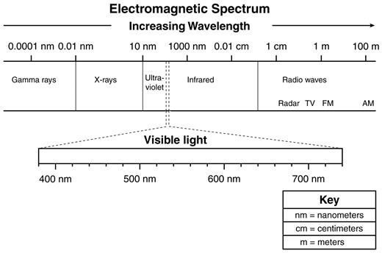  Energy at which wavelength is most likely to be absorbed by the ozone layer in Earth’s stratosphere?
 | A. 0.10 nm
 | B. 250 nm
 | C. 0.01 cm
 | D. 95 m

13. | What is the primary energy source driving circulation of ocean currents on Earth?
 | A. geothermal heating
 | B. planetary rotation
 | C. solar heating
 | D. lunar tidal forces

14. | The Gulf Steam current travels from the equator towards Europe.  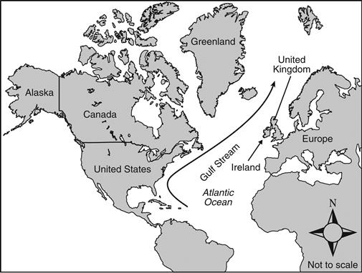  If the Gulf Stream stopped flowing, which environmental change would most likely occur?
 | A. More reefs would develop in the waters near the eastern Greenland coastline.
 | B. Water temperatures in the Northern Atlantic Ocean would be much hotter.
 | C. Land masses in the Northern Atlantic Ocean would have colder climates.
 | D. Most of Europe would be flooded because of rising sea levels.

15. | St. Augustine, Florida, and San Antonio, Texas, are located near the same latitude. However, average winter temperatures in St. Augustine are higher than in San Antonio.  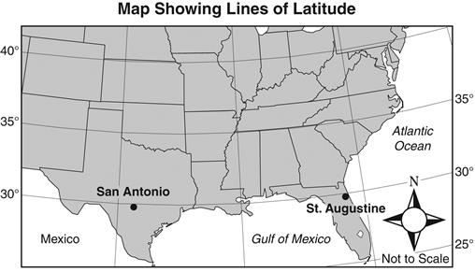  Which most influences the milder temperatures of St. Augustine, Florida?
 | A. increased cloud cover
 | B. reduced solar radiation
 | C. distance north of the equator
 | D. nearness to ocean currents

16. | Ocean currents affect global climates. The Great Ocean Conveyor Belt is shown.  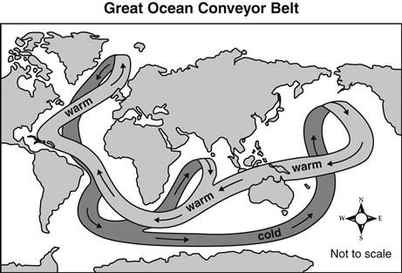  Which is most likely the mechanism that drives the current to continue to circulate?
 | A. surface winds
 | B. density currents
 | C. rotation of Earth
 | D. gravity of the Moon

17. | 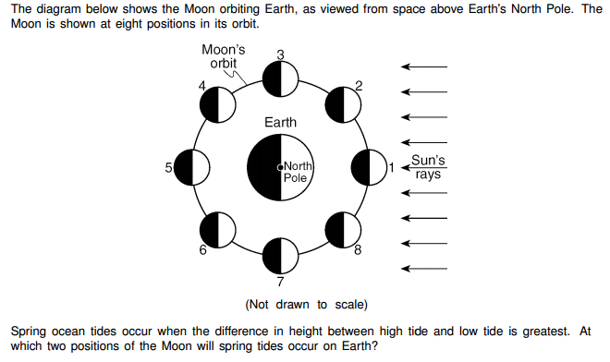
 | A. 1 and 5 |  | B. 2 and 6
 | C. 3 and 7 |  | D. 4 and 8

18. | The Coriolis Effect provides evidence that Earth
 | A. rotates
 | B. has a tilted axis
 | C. has seasons
 | D. revolves

19. | 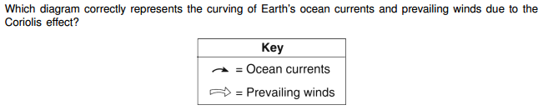
 | A. |  | B.
 | C. |  | D.

20. | The primary cause of surface ocean currents is
 | A. atmospheric winds
 | B. atmospheric precipitation
 | C. ocean water evaporation
 | D. ocean floor earthquakes

