FINAL EXAM PRACTICE #3: Meteorology, Climate, and Ecology

1. | Clay is watching the weather to prepare for a trip to the beach tomorrow. The forecast predicts that a low-pressure system will move in overnight. Which type of weather can Clay most likely expect in the morning?
 | A. foggy
 | B. sunny
 | C. clear and colder
 | D. cloudy and rainy

2. | The diagram illustrates an airflow pattern that occurs near the equator. Location X is on the equator.  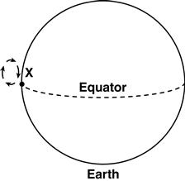  Rising moist air causes the frequent occurrence of which weather condition at Location X?
 | A. high surface pressure
 | B. cloudy and rainy
 | C. cool and dry
 | D. low evaporation rate

3. | Tornadoes can occur throughout the United States. One area where most of the tornadoes occur is known as Tornado Alley.  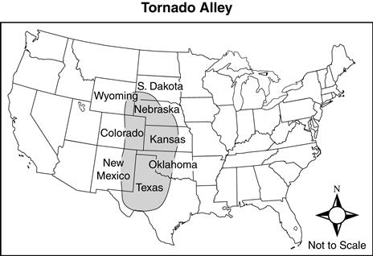  Which environmental factors most likely impact the formation of tornadoes in this area?
 | A. high pressure systems colliding with other high pressure systems
 | B. cold dry air and warm dry air moving towards each other
 | C. low evaporation rates and windy conditions
 | D. cool dry air colliding with warm moist air

4. | The arrows on the map represent the movement of air masses across North America.  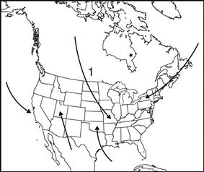  Air mass 1 would most likely bring which weather conditions to a region?
 | A. cool and dry
 | B. warm and dry
 | C. cool and humid
 | D. warm and humid

5. | Which statement best explains why the force of a hurricane diminishes as the hurricane moves over land?
 | A. A high pressure area develops.
 | B. The sea level rises on the coast.
 | C. The winds start to spin clockwise.
 | D. The supply of warm, moist air decreases.

6. | As a warm moist air mass moving northward collides with a strong cold air mass moving southward, what observations will most likely be made?
 | A. Thick fog develops.
 | B. Temperatures increase.
 | C. Clouds begin to form.
 | D. Winds die down.

7. | 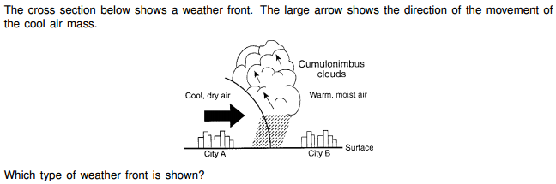
 | A. warm front
 | B. cold front
 | C. occluded front
 | D. stationary front

8. | 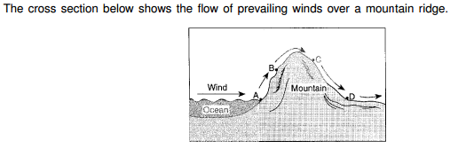  Which locations are most likely to receive precipitation?
 | A. A and B
 | B. B and C
 | C. C and D
 | D. A and D

9. | 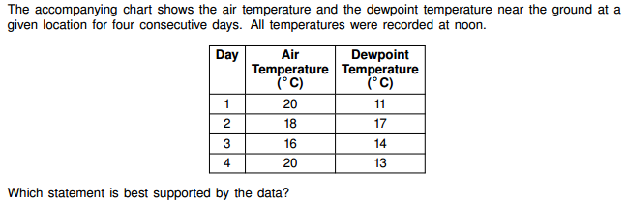
 | A. Relative humidity was highest on day 1.
 | B. The greatest amount of water vapor was in the atmosphere on day 2.
 | C. The base level for cloud formation was highest on day 3.
 | D. The chance of precipitation was greatest on day 4.

10. |  | Snowfall is rare at the South Pole because air over the South Pole is usually
 |  | A. rising and moist
 |  | B. rising and dry
 |  | C. sinking and moist
 |  | D. sinking and dry
11. | Global warming affects sea levels. Which of these is a likely consequence if the trend of global warming continues in coming decades?
 | A. Melting glaciers will cause flooding of coastal towns and cities.
 | B. Melting glaciers will cause flash flooding in mountainous regions.
 | C. Evaporation will cause the formation of fjords and U-shaped valleys.
 | D. Evaporation will cause sea levels to drop enlarging coastal areas.

12. | A student learning about how carbon exists in various forms as it moves to different parts of the carbon cycle reads the following sentence.  Atmospheric carbon is the most important threat to the health of the biosphere.  In which way is carbon a threat to the biosphere?
 | A. Carbon dioxide in the atmosphere serves as a carrier for diseases.
 | B. Carbon atoms bond with water vapor to create acidic precipitation.
 | C. Carbon dioxide gas can effectively trap heat in the atmosphere.
 | D. Carbon compounds can cause genetic damage when burned for fuel.

13. | The average temperature of Earth has increased approximately 0.8°C in the last one hundred years. Which of the following do researchers most attribute to this temperature increase?
 | A. increased population in third-world countries
 | B. increased use of fossil fuels
 | C. the solar flares reaching Earth
 | D. the lower amounts of carbon dioxide

14. | The average global ocean temperature in 1912 was 15.8°C, and in 2011 this temperature was 16.5°C. Corals are sensitive to the temperature of ocean water. The health of corals is a concern if the ocean temperature continues to rise. Which of these is a likely prediction based on the current trend in ocean temperature data?
 | A. speciation of coral reefs
 | B. bleaching of coral reefs
 | C. accelerated growth of coral reefs
 | D. enhanced fish predation on coral reefs

15. | An area is described as having mild temperatures in the summer and being cool and rainy in the winter. On a day in May, the area experienced snow. Which best describes this day in terms of weather and climate?
 | A. The weather was different from the normal climate for the area.
 | B. The climate was different from the normal weather for the area.
 | C. Weather and climate were different from the normal properties for the area.
 | D. Climate and weather were changing into a new set of normal properties for the area.

16. | Deforestaton increases the greenhouse effect on Earth because deforestation causes the atmosphere to contain
 | A. more carbon dioxide, which absorbs infrared radiation
 | B. less carbon dioxide, which absorbs short-wave radiation
 | C. more oxygen, which absorbs infrared radiation
 | D. less oxygen, which absorbs short-wave radiation

17. | For weeks after a series of major volcanic eruptions, Earth's surface air temperatures are often
 | A. warmer because ash and dust decrease atmospheric transparency
 | B. warmer because ash and dust increase atmospheric transparency
 | C. cooler because ash and dust decrease atmospheric transparency
 | D. cooler because ash and dust increase atmospheric transparency

18. | During an El Nino event, surface water temperatures increase along the west coast of South America. Which weather changes are likely to occur in this region?
 | A. decreased air temperature and decreased precipitation
 | B. decreased air temperature and increased precipitation
 | C. increased air temperature and increased precipitation
 | D. increased air temperature and decreased precipitation

19. | Changes in the chemical composition of the atmosphere that may produce acid rain are most closely associated with
 | A. insects that excrete acids
 | B. runoff from acidic soils
 | C. emissions from burning coal
 | D. drilling for oil

20. | One environmental problem caused by the use of nuclear power as an energy source is the
 | A. destruction of the ozone layer
 | B. disposal of wastes
 | C. production of acid rain
 | D. accumulation of carbon dioxide in the atmosphere

21. | Look at the list of changes to an ocean ecosystem.  1. extinction of some species of fish  2. loss of food supply for predator species  3. loss of all species in the ecosystem  4. weakening of the sustainability of the  ecosystem  Which of these are the most likely results of overfishing in ocean ecosystems?
 | A. 1 only
 | B. 1 and 2 only
 | C. 1, 2, 3, and 4
 | D. 1, 2, and 4 only

22. | Corn is widely being used in the United States to make ethanol for use in automobile fuel. How might the overproduction of corn negatively affect the environment?
 | A. decreasing soil fertility
 | B. decreasing oil transportation
 | C. increasing the greenhouse effect
 | D. increasing carbon dioxide emissions

23. | Since the 1900s, the human population has increased in Florida. As a result, much of the fresh water that had previously made its way to the Everglades has been diverted for human use.  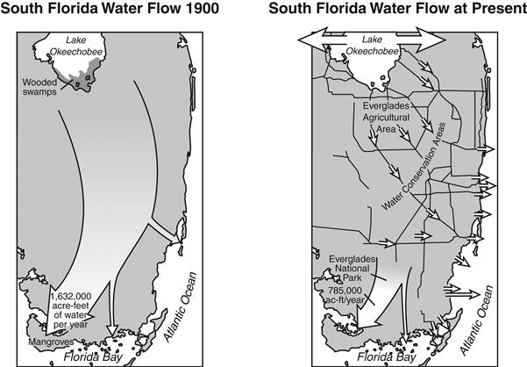  Which would be the most likely effect of decreased flows of fresh water on the ecology of the Everglades?
 | A. an increase in the amount of erosion in the Everglades
 | B. a decrease in the amount of salt water in the Everglades
 | C. a decrease in the populations of native plants and animals
 | D. an increase in the reproductive rates of native plants and animals

24. | Nitrogen is a nutrient needed by plants for growth. Nitrogen is naturally cycled into the soil where it is rapidly absorbed by plants. What would a farmer most likely do to replenish nitrogen that was depleted from the soil?
 | A. use water that is enhanced with phosphates
 | B. add fertilizer to the soil to provide a source of nitrogen
 | C. use genetically altered crops that fix their own nitrogen
 | D. add bacteria to the soil in order for the crop to grow stronger roots

25. | Vetiver grass is planted by farmers along the borders of corn fields.  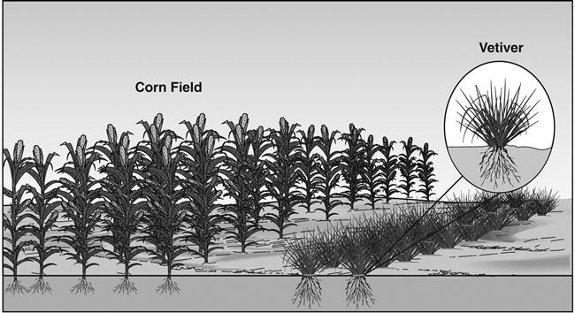  Which process does the vetiver grass most likely help farmers reduce?
 | A. chemical weathering
 | B. insect infestation
 | C. freezing of crops
 | D. water erosion

26. | While on a trip to Peru, Carlos saw that a mountainside had been terraced by the ancient Inca Indians. The Incas had terraced the side of the mountain to grow food.  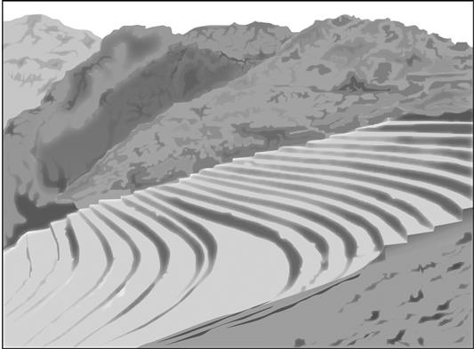  Which other purpose did the terracing of the mountain serve?
 | A. It provided a transportation system.
 | B. It encouraged wild plant growth.
 | C. It helped control erosion.
 | D. It prevented flooding.

27. | Which human activity most likely contributes to the solid waste pollution in streams and landfills?
 | A. using natural fertilizers on lawns
 | B. buying products packaged in disposable containers
 | C. combining leaves and grass clippings with paper products to use in composting
 | D. recycling glass, paper, and aluminum products

28. | Land subsidence (ground level dropping) is most likely an indication that
 | A. sediments are being deposited.
 | B. water is being polluted.
 | C. rocks are being weathered.
 | D. ground water is being depleted.

29. | The human population is increasing every day. How does this increase in population affect the natural resources that maintain humans?
 | A. increases the supply of resources
 | B. decreases the amount of resources
 | C. results in less demand for resources
 | D. improves the quality of the resources

30. | 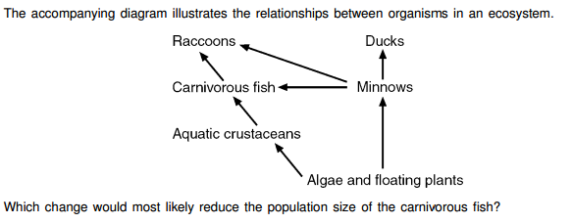
 | A. an increase in autotroph populations
 | B. a decrease in the duck population
 | C. an increase in the racoon population
 | D. a decrease in pathogens of carnivorous fish

31. | In order to reduce consumption of nonrenewable resources, humans could
 | A. burn coal to heat houses instead of using oil
 | B. heat household water with solar radiation
 | C. increase industrialization
 | D. use a natural-gas grill to barbecue instead of using charcoal

32. | The rapid destruction of tropical rainforests may be harmful because
 | A. removing trees will prevent scientists from studying ecological succession
 | B. genetic material that may be useful for future medical discoveries will be lost
 | C. energy cycling in the environment will drop
 | D. the removal of trees will limit the construction of factories that will pollute the environment

