Human Impact Station Rotation

Global Warming video
Begin by watching the National Geographic video on “global warming” on the computer at your station.
What are the two main gasses that cause global warming? ________________________ ___________________________
Using the picture on the board, describe what has happened and how it relates to global warming.

Invasive Species Station

Define Invasive Species-

What does an invasive species do to an ecosystem? What effect does it have on an ecosystem?

Describe the effect the cane toads had on the environment.

Habitat Destruction Station
Using the article in front of you, Define Habitat Destruction:

Brainstorm all the ways that human activity has caused habitat destruction:

Define Biodiversity.

Draw a picture showing biodiversity:

Read the “where is it happening” part of the article (on the backside) and give four examples of how habitat destruction is reducing biodiversity in the world.
- 2.

3. 4.

Acid Rain Station
Define Acid Rain.

Name the two chemicals that contribute most to acid rain: ___________________________ ________________________

Using the “Measuring Acid Rain” article, place a blue asterisk (on your pH scale) under the pH of most rain water.

Place a red asterisk (on your pH scale) under the pH of acid rain.
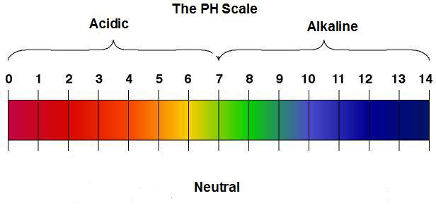

Using the images at your station, describe the effects of acid rain on statues and forests.

Overfishing
Read the article at this station.
What causes overfishing?

What is causing overfishing?

Why is overfishing a problem?

List some things you can do to help overfishing.

Human Population Growth
Go to http://www.pbs.org/wgbh/nova/worldbalance/
Click on “Human Numbers through Time”, then Launch Interactive. Go through the nine slides and pay attention to the dates. Draw a graph to display human population growth over the past 1000 years. Start with AD 50 and end with 2050.

Go back to the home page, and click on “Material World” on the left hand side of the page. Read the story about the family in India. Compare and contrast their possessions with your possessions.

Using the data under the paragraphs, provide reasons as to why people live the way they do in India.

